c-Lock: a Distributed Lock Manager

Nachiket Patil*, Garima Tiwari*, Hrishikesh BJ#, Rohan Indurkar#, Shweta Shridhar#
*Department of Computer & Information Science & Engineering,
#Department of Electrical and Computer Engineering,
University of Florida, Gainesville, FL, 32611, USA
{nachiketpatil, gtiwari14, hrishikeshbj, rohanindurkar, shweta.shridhar}@ufl.edu

Abstract — since the advent of cloud computing, various large-scale distributed computing paradigms such as grids, clusters and other cloud services have been employed to handle an ever increasing flow of data. This data is stored remotely and accessed in an ad-hoc manner. Hence it becomes necessary to have an effective concurrency control (locking) mechanism in order that the shared storage can be collaborated among multiple users without collisions and loss of data integrity. This paper covers the design and implementation of c-Lock a Distributed Lock Manager (DLM). DLM is essentially a distributed infrastructure service for a cloud system. The DLM provides software applications a synchronized mechanism to access shared resources on cloud/ distributed system. In this project build a DLM with an interface through which a user/ application can hit a “DLM host” and request for locks using user apps (simple web service). The DLM hosts communicate among themselves based on Gossip protocol and manage a database of shared resources. The paper also deals with the deadlock detecting mechanism employed with c-Lock. The project can be taken further to build long time lock management, leader election, etc. The project doesn’t need any cloud services as we build the cloud infrastructure itself.

Keywords— Distributed systems, Cloud Computing, Locks, Distributed Lock Manager, Deadlock, Gossip, Quorum, Leader Election, etc.
- Introduction
In Recent past the number of computer users, user devices and user applications has increased exponentially. With this increase, the data has grown exponentially too. Due to the massive data generation and limitations of the traditional computing system such as insufficient storage, big data processing and networking there was a need for a system which would be able to provide larger data storage, faster data processing and networking thereby facilitating scalability as the demand increases. This led to emergence of distributed systems/ Cloud Computing.
Cloud computing enables convenient, parallelized and cost-cutting and on demand distributed computing; facilitating shared resources thereby maximizing the effectiveness of shared resources. It not only enables the user to share the resources but also reallocate resources dynamically. Cloud computing uses a group of machines to work as a single unit in order to solve a large scale problem. The basic idea is instead of scaling up single machine to work faster and faster, effectively increasing cost of the machine, scale outwards and use multiple machines simultaneously to perform tasks in parallel.
With such a large amount of data and large number of applications trying to access this data, comes the challenges and complexities of distributed/ cloud computing. One of the most important areas is synchronization of access to data.
Example: On a computer system, multiple user processes are trying to access a file. Some processes intend to write to the file some want to read the file. If all processes try to execute the operation they intend, there is no guarantee of integrity of data in the file. To achieve data integrity and consistency, operating systems use synchronization mechanisms that ensure sequential access to data using locks. Normally at system level mutex/ semaphores work for synchronization. These constructs are part of operating system that user programs can use.
But in case of distributed systems where data spans more than one disk/ system and there may be more than single replica of the data, much more sophisticated synchronization mechanism is needed. This synchronization is achieved with Distributed Lock Managers (DLM).
DLMs are designed and are intended for coarse grained resources. For a DLM resource can be user defined instead of system defined fixed resources. DLM can take a file, a data abstraction, a service, etc. as a resource. At the abstraction level of distributed system, DLM provide an interface that hides replicated or distributed nature of data or services. The distributed nature of the system in case of cloud or the namesake (distributed systems), the communication delay between the resources and the user application is also a major factor for designing that system. Considering this network delay or randomness of network the basis of any remote resource is that the resource is coarse.
- Related Work And Motivation
Distributed Lock manager is an essential service for any distributed system or a cloud system. Over the years there have been many attempts to implement DLMs. Initial works towards creating a DLM are RedHat’s own DLM and Oracle’s Lustre DLM for their cluster file systems. Most of the basic concepts of types of lock, and distributed deadlock detection are based on the algorithms implemented in these DLMs.
Amazon services use Amazon’s internal DLM for their synchronization and other services like resource state management and leader election. Google’s Chubby lock manager is used by Google’s services. These are some of the most advanced DLM implementations.
Every competitor in cloud market has its own implementation of DLM. These DLMs implement all the functionalities in very similar way. Most of these systems use generic concept of a resource (coarse grained resources or loosely coupled systems), database of resources and the locks are maintained in memory for better performance. Most of these implementations defer in the underlying technology and the interface that are exposed to the user. These interfaces depend on the intended use of the DLM.
Apache ZooKeeer is product of Yahoo’s open source development projects. This DLM is open source and implements most of the advanced features of a DLM. We are planning to achieve as many of these features in c-Lock as we can. In future we plan to compare Apache Zookeeper and c-Lock for features and performance.
For RedHat’s DLM and Oracle’s Lustre DLM a lock is a means of synchronization among the services that work on the distributed file-system by the distributed operating systems. The locks emulate the mutex construct of stand- alone operating system. The lock is stored with the replica of the data that the lock operates on. These systems don’t allow a user to explicitly access the locking API. The drawback with Google’s Chubby DLM service and Apache ZooKeeper’s locks is that they allow explicit lock creation and locking APIs for users but the locks can be created for any resource in the system. For the lock creation, the resource must be present in the system. Also there is no particular state associated with the lock that is registered with the lock manager which the locking application can lock the resource against. There is no record of the state of the resource in the system that the request of lock the resource in a particular state can be checked against. The concept of lock very generic with these DLMs.
In this paper we discuss the design and implementation of c-Lock. A DLM with specific approach toward distributed locks with state management built in the system and deadlock detection.
- Architecture
We have implemented a Distributed Lock Manager with Java and a local Database management system. The DBMS used is Sqlite a very lightweight database application. The c-Lock includes a simple web service end point which the users can hit for communication with c-Lock. This end point is a Apache TomCat based RESTful service.
- C-Lock End Point:
c-Lock endpoint is essentially a web service exposed to users/ user applications. The user is provided a library API using which the user communicates with DLM through this end point. The communication messages have a standard format and use REST interface. Being a distributed system, there can be more than one end points exposed. Each c-Lock host has its own end point. Multiple end points mean better availability and robustness. User may connect to any end point and have same functionalities exposed and access to all resources registered or all the locks created.
- C-Lock Host
A c-Lock Host is nothing but a server of our DLM. Each c-Lock host maintains a replica of the database of all registered shared resources. It establishes connection with other DLM hosts and carries out communications. It maintains a list of granted locks and lock requests in memory and executes deadlock detection algorithms on these lists.
Each host contains one replica of resource database as well as in memory replica of the locks granted. Each host communicates to most of other hosts before making decision of lock granting or rejection. The communication with other hosts is carried out with innovative Gossip protocol. This communication is message based and the number of messages sent is significantly less than the number of messages sent in broadcasting the message as is the case with most of other DLM systems.
Realistically we consider all hosts may not be connected to all other hosts and Gossip protocol performs much better than broadcasting messages. We adopt the eventual consistency model for better performance, reliability and high availability reasons.
- Workflow
Working of a c-Lock involves executing communication and algorithms on 2 planes: user plane and system plane.
- User plane
User plane involves communication between user and a DLM for:
- User registers a resource.
- User requests a lock/ maintains a lock.
- DLM grants or rejects a lock.
- DLM detects a deadlock and warns user about it.

- System plane
At System plane, the execution starts when a user hits a DLM host with request. Figure -1 explains the control flow in c-Lock. The DLM host that user communicates initiates further steps:
First as user registers a resource, the DLM Host stores the record in local DB and lets other DLM Hosts know about new resource.
- When a user requests a lock, the DLM Host checks local DB and if lock is not grantable then communicates to user on user plane.
- Else, sends a message to other DLM hosts with the lock request.
- Other DLM hosts on receiving the request from initiating lock request check their local database and respond accordingly.
- The initiating DLM host checks the replies from other DLM hosts and replies to user appropriately on user plane.
The communication between the DLM hosts is based on Gossip protocol and the decision to grant the lock is based on Quorum.
These are two separate phases of communication to provide security of communication. The hosts when receive a message if the message is on system plane, there are separate workflows that work on the message than the workflows working on the messages received on User plane.

Quorum: A quorum is a decision making mechanism. It asks for votes from all members (in this case all the c-Lock hosts) of the quorum for votes whether a lock can be granted or not. All members vote either in favour of granting the lock – positive reply or against granting a lock – negative reply. The c-Lock host keeps track of all the replies from other c-Lock hosts and makes decision based on these replies. If more than half the DLM hosts reply positively to grant lock or reject it, appropriate decision is taken by initiating c-Lock Host.
This decision is taken as soon as the number of positive or negative votes reaches more than half the number of c-Lock hosts in the system. C-Lock does not wait for all the replies to reach to the initiating host.

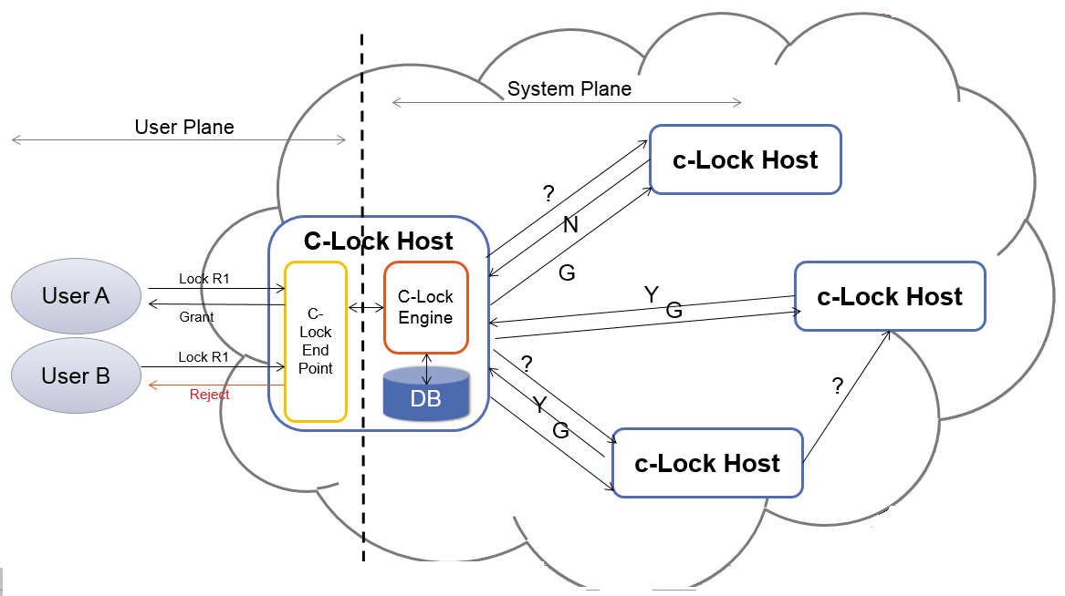
Figure 1: Control flow of c-Lock

Gossip Protocol: It is a computer-to-computer communication protocol used mostly in large scale distributed systems. In Gossip protocol, each node has some information associated to it which includes the connections it has with other nodes in the network and the messages that passed through the node or some mathematical parameters that drive the communication through the network. The working of Gossip protocol is explained in detail in the reference paper by Kempe, Dobra, Gehrke, et all. [4].
The basic working of gossip can be explained as: A communicating node in network can initiate the protocol by sending a message on the network to one of its neighbours. A neighbour node is a node that has direct link with current node. It randomly selects a node which is available in its list of neighbour nodes. The data is then shared between the nodes. The receiver node replies with the information that is available to it. In this way, both sender and receiver node updates their data by merging the information available to both. Then both nodes select random neighbour n their neighbour list and forward the message and merge the information. This protocol is much more efficient and faster compared to token ring or flooding algorithms usually used in distributed computing.
In case of token ring algorithm, the time taken for the message to travel complete network is order of number of nodes in the network. This time complexity is unrealistic for critical services like a DLM and if a node in ring fails, whole ring fails. Flooding algorithm like broadcasting a message by each node once it receives a message is normally used by other DLMs. This flooding works in logarithmic time but creates messages of the quadratic order of the number of nodes in the network, i.e. if there are n nodes in the network, time to reach all nodes log n, and the number of messages created in network is n². Figure 3 depicts working of a flooding algorithm in just 2 stages. 4 nodes with 2 nodes broadcasting the message create 8 messages all nodes broadcasting one message creates 16 messages in network. The DLM systems handle thousands of lock requests each second, the number of messages created in the network with 10 DLM hosts handling 1000 requests per second is 10⁷. This is very high bandwidth usage.
Solution is Gossip protocol. Gossip needs time of the order of natural logarithm of the number of nodes in the network which is similar to flooding algorithm and the number of messages generated is of the order of the number of nodes in network multiplied by the natural logarithm of total number of nodes in the network i.e. if there are n nodes in the network then time taken to reach all nodes in the network is log n and the number of messages created in the network is n log n. Figure 2 depicts working of a gossip protocol. Here reaching all 4 nodes in the network takes just 3 messages. The mathematics behind these results is explained in detail by Kempe, Dobra, Gehrke [4] and is too complex to be part of this paper.
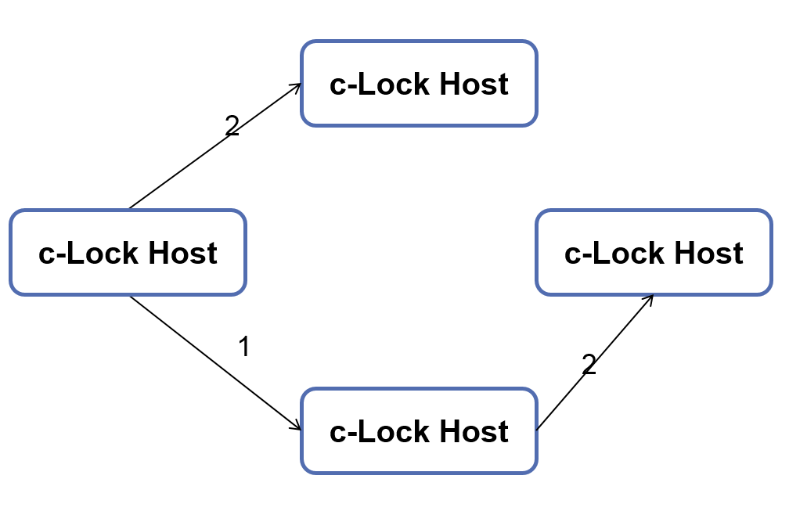
Figure 2: Communication among c-Lock hosts using of Gossip Protocol.

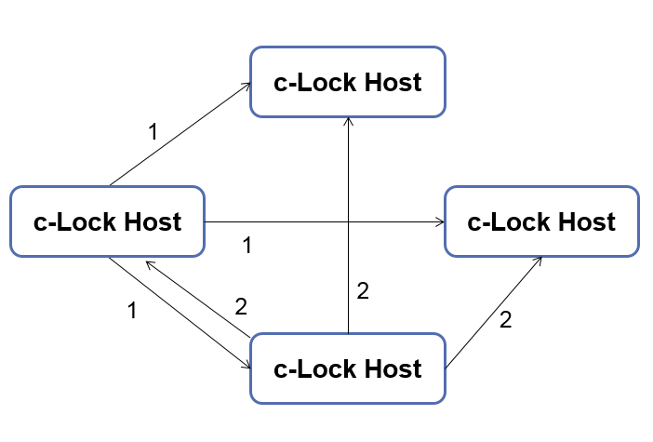
Figure 3: Communication with broadcasting a message
With Gossip protocol, initiating communication is easy but stopping the communication is quite difficult. There are 2 ways to implement Gossip protocol:
- Each node stores the id of message that passes through it and forward a message fixed number of times through a node.
- Associate the message with mathematical parameters, manipulate the parameters at each node of the network so that eventually they converge.
We know the number of nodes in the network hence we use first way to implement Gossip. Each node after receiving a message, if the message is received first time, forwards the message to random neighbour and creates new message and sends it to another random neighbour else if the message is received before, the message is just forwarded to random neighbour. To achieve complete coverage of network in logarithmic time, we forward and create a message for first time and each message has hop count associated with it. Once a message’s hop count reaches log n (where n is number of nodes in network), the message is dropped and not forwarded.

- Implementation Details
  - C-Lock End Point
The c-Lock is exposed to the clients as a web service. The listener for the user messages is a RESTful web service based on Apache Tomcat Server. The end points and communication protocols with the message structure is defined with the server configuration in web.xml. The servlets are created using JAX-RS (Jersey). The interface exposed to user implements only 4 (CRUD) functions: Create, Read, Update and Delete based on REST API. The End point receives the message, parses it and puts the message on the c-Lock Engine’s message queue for further processing. The connection details are passed with the message so that worker can communicate to the user module directly without disturbing the listener.
  - C-Lock client
The user is provided with library classes for communicating with the c-Lock end point. These classes hold the formal definitions of messages. The library also holds the Leader election co-ordinator module. This module is separate thread that runs for the lifetime of the application and maintain the leader status. There is another special purpose thread included in the client library, the heat beat creating thread. This thread periodically sends message (called heartbeat) to c-Lock end point to maintain the locks on the resources. For long term lock management for critical resources, we intend to extend this thread to maintain lock as well for resources. If the thread (i.e. the user) fails to heartbeat into c-Lock periodically, we assume that the user system has failed and the lock is revoked. The heartbeat rate expected is one message per minute. If the client misses 2 heart beats, the lock is revoked by c-Lock engine and next time when user tries to heart beat for revoked lock, error message is sent back to the user stating that the lock has been revoked.
The client library supports API for following functions:
- Create Resource: creating new resource. User can register a resource with resource name and a state and the unique ResourceId is returned by c-Lock. For a user the resource name is also unique but not unique across users.
- Query Resource Id: User can query for unique resource Id of a registered resource. C-Lock searches registered resource based on the resource name and user name to determine the unique id.
- Delete a resource: User can delete a resource with unique Resource Id.
- Lock a Resource: User can lock a resource in a particular state that is registered with the resource Id with a particular Lock Type. If Resource Id, state and lock Type don’t match, and error is sent back by c-Lock.
- Release Lock: User can release lock on a resource just using Resource Id.
- Register Application as Leader: User can register an application as candidate for leadership.
- AmITheLeader(), Relieve(): The user application can use this method to acquire the leadership and release the leadership.
  - Resource Table
We store the resources that are registered with c-Lock into local Database at each c-Lock host. These records are replicated across all the c-Lock hosts and these records of resources live much longer than actual lock. We need only one table to store the records of resources and their state, we use very light database module sqllite 3.7 for java. In this table c-Lock maintains following details for each resource.
- ResourceId [Text] – A unique id for each resource. This resource Id is generated from the resource name, user name and a random number.
- Resource Name [Text] – Name of the resource as mentioned by the user.
- User Name [Text] - Id of the user who has registered the resource. Usually in cloud systems, every resource and a user has a unique Id.
- State [Text] – This is a state that the resource can hold. If this field is empty means the resource doesn’t have any state. If a request comes to lock the resource with state not present in DB, the request is rejected. There is one record for each state for each resource in the database.
The user can query for resource Id with user name and resource name. In this case only the resource Id will be sent back to the user.

  - C-Lock Engine
The Engine is the heart of the c-Lock DLM. The c-Lock Engine has 3 major components. ServerListener, ClientListener and LockWalker.
Before the ServerListener and the ClientListener work on the message, the message caught by the c-Lock endpoint is parsed to extract all the necessary fields. The message includes following fields:
- MessageId: unique id of the message, used in forwarding the message by Gossip.
- UserId: unique user Id, necessary for several operation in c-Lock: identifying resources, locks and deadlocks.
- Operation: Operation to be performed, e.g.: CreateResource, Lock, Release, etc.
- ResourceId: Unique identifier of resource.
- ResourceName: Name of the resource.
- ResourceState: State to create or lock the resource with.
- LockType: Type of the lock.
- Descriptopn: Description of message, may contain error in case of any.
ServerListener The ServerListener listens for internal communication messages from other servers. Once the message is received, it checks the shared list of locks granted. If the resource is not locked or the requested lock can be granted and no other requests with higher lock level are made, the ServerListener replies the c-Lock host with positive reply, else negative reply is sent. At the same time, the message is forwarded to other hosts for gossip based communication.
ClientListener
The ClientListener continuously polls the message queue for any incoming messages. If there is a message in the queue, a ClientWorker thread is created to handle the message. ExecutorService with fixedThreadPool is used to maintain a fixed maximum number of threads running at a time in the system for c-Lock.
Each worker evaluates the message based on its content. The message may be about creating a resource/ deleting a resource or reading a resource, or it may about requesting a lock or releasing a lock. The database based operations and the lock related operations are executed locally first and if necessary taken to next level for Quorum.
In Quorum phase, if the operation is about creating or deleting a resource, it is taken care of by each c-Lock host and forwarded to another host without any reply; no quorum is needed. But in case of lock requests, the message is sent to all c-Lock hosts and based on their local states, they reply back to the requesting host. Then based on majority of replies positive or negative, the user is sent back a reply with grant or reject a lock.
LockWalker:
The Lockwalker is the module responsible for revoking locks when the user application fails to send heartbeat to c-Lock. Each lock in c-Lock locks list has a count associated with it. The LockWalker increases the time each time it runs over the list. If the count is greater than threshold value, it revokes the lock. Each time c-Lock receives a hear beat from the user for a lock, it resets the time to zero so that it cannot get revoked by the LockWalker. DeadLock detection is also a part of LockWalker. We have configured to run deadlock as ScheduledThreadPoolExecutor. This thread is run every minute and the lock revocation threshold timeout is 2 minutes.

- Types of Locks
There are 6 types of locks. Each lock has meaningful user scenarios.
TABLE I
Cross locking
Current Lock | Granting other locks
Current Lock | NL | CR | CW | PR | PW | XL
NULL (NL) | T | T | T | T | T | T
Concurrent Read (CR) | T | T | T | T | T | X
Concurrent write (CW) | T | T | T | X | X | X
Protected Read (PR) | T | T | X | T | X | X
Protected Write (PW) | T | T | X | X | X | X
Exclusive (XL) | T | X | X | X | X | X

The locks are implemented as enum type and each resource has a Distributed lock associated with it. This distributed lock has a list of individual locks granted to various users for that resource. The system maintains a list of all distributed locks granted as shared memory. New lock requests are considered on severity of the lock. If a severe lock request is made then no new lock requests are considered with lower lock severity. Table 1 and Figure 4 explain the interoperability of locks and severity of locks.
Each lock type has a meaning associated with it and can be used in various related use cases. Some of these use cases according to the lock type are:
Null Lock (NL): A user owns a resource but has not locked it, other users may lock it.
Concurrent Read (CR): A web page on a server is exposed to the world for reading.
Concurrent Write (CW): A shared queue is exposed to multiple application to write into.
Protected Read (PR): A user is reading a shared configuration file. Any changes to it are not allowed when the user is reading it.
Protected Write (PW): A user is writing a configuration file. Only concurrent read is allowed with it.
Exclusive lock (XL): This is traditional exclusive lock. No other lock is compatible with this lock. A system is shut down for upgrade, the system is locked with XL and no other application can have any lock on it. The leader election uses XL for locking leadership of a particular application.
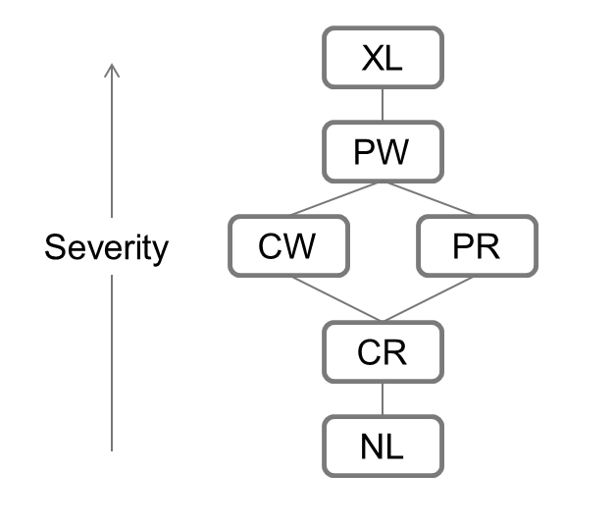
Figure 4: Severity of locks
The lock types are enumeration fields with which, the maintenance of severity and interoperability of lock types is quite easier to implement with enumeration comparison operators. If a lock request comes for higher lock than the highest lock for the resource, the lock is granted. If the requested lock is lower than the highest lock for the resource is question, the lock is rejected with special cases of concurrent write (CW) and exclusive lock (XL). CW is granted only if current locks are of type concurrent read (CR) and null lock (NL) and exclusive lock (XL) is granted when there is no lock on the resource.

- Additional Features
  - Deadlock detection: Each DLM runs a deadlock detection algorithm on its local data and communicates with other hosts to confirm it and returns to user appropriately.
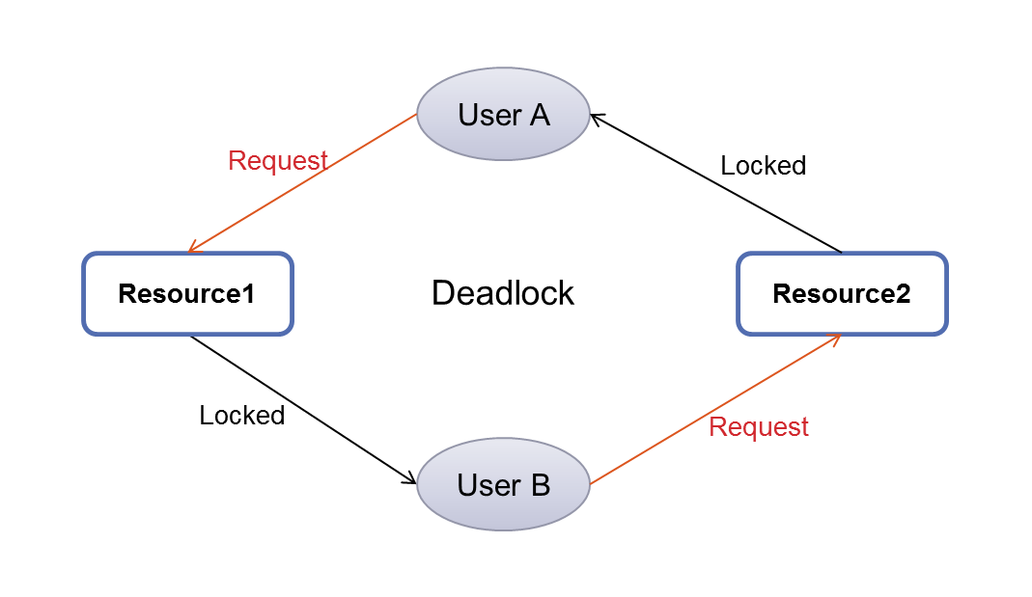
Figure 5: Cyclic resource allocation graph depicting a Deadlock

The deadlock detection algorithm is run locally on each c-Lock Engine as a part LockWalker. Every minute this LockWalker scans the locks that are granted and the requests that are made. The granted locks and the rejected requests are stored in memory of the c-Lock engine. Simple algorithm that uses reverse tracking in resource allocation graph is used to find the deadlocks. The algorithm is:

Algorithm 1: Deadlock detection with reverse tracking
Of resource allocation graph

01| global synchronized lockList, requestList
02| find_deadlock(resource, user, org_resource) {
03| requestList ⬅ getRquests(user);
04| for each (request : requestList) {
05| if(request.resource = org_resource) {
06| set Deadlock = true for all traversed
07| resource Locks
08| } else {
09| lock ⬅ getLock(request.resource)
10| find_deadlock(lock.resource, user,
11| org_resource)
12| }
13| }

If there are entries are present in locks list e.g.: Resource1 locked by user B and Resource2 locked by User A. and in rejected requests list there are records of User A reqesting resource1 and User B requesting resource2. Then while walking Locks, if tracing locks back, we can determine deadlock is present. The Lockwalker also maintains the time for which the lock is maintained by the user.

  - Leader Election: A special API library that uses DLM for leader election with user periodically sending heartbeat to DLM. Same can be useful in long term lock management. The User module that user uses has functionality implemented that it heartbeats periodically to c-Lock. We expect once a minute.
User must register an application as candidate for leadership with application name. And the user can acquire the leadership status and check its status with call AmITheLeader(). This API in c-Lock client library first checks whether the application is registered as resource or not, if not registered, then create a resource with name as application name and lock it with exclusive lock (XL). This way the client library acquires a lock and returns true for the call. If there is another leader registered for same application name, it then returns false to the calling application. If a user application attains leader status, the client sends periodic heartbeats to the c-Lock. The LockWalker explained in previous point increases the counter of timer. If the counter is greater than 1 then the user loses leadership or the lock is revoked. Each heartbeat that c-Lock receives it resets this counter. Similar to lock management, if the client application fails to send heart beat to c-Lock host for 2 times, the lock is revoked i.e. the leadership is lost for the application.

  - State Management: c-Lock maintains a database of states and DLM handles state transition of resources/ processes. Once the user creates a resource, states are associated with it. These states can be added afterwards but not reduced. The lock is granted only if the resource doesn’t have a lock or it is locked in the same state. State management can be used by the user independent of locks.

- Evaluation
The test bed: The c-Lock host can be deployed on either MS Windows or Linux based hosts. The c-Lock runs on Apache TomCat 7.0 and uses RESTful API created with Jersey (JAX RS) 2.4.1.
We deployed-Lock on one Windows 7 based host and two Ubuntu 12.04 based hosts, all running commodity hardware. The clients were testing applications run on 2 Windows machines. We measured the performance of c-Lock on single deployed host and 3 hosts deployed with 2 clients firing all requests. The results found are approximated. This c-Lock implementation doesn’t include a name server hence all the nodes were connected on a commodity network device via LAN.
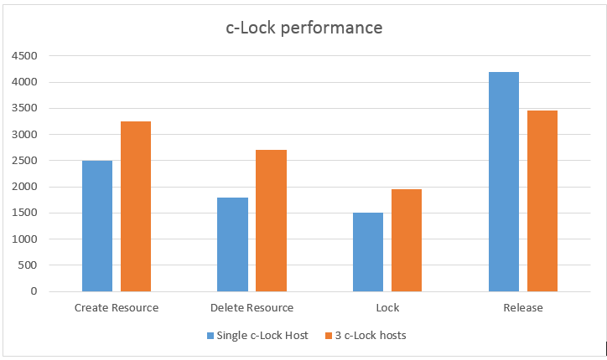
Figure 6: c-Lock performance
We observed that performance of c-Lock is comparable with the performance of Apache Zookeeper in single host deployment environment. With 3 host deployed in the network, we saw marginal improvement in the performance of c-Lock.
Create Resource: The create resource operation needs to create a database entry in the resource table in all the hosts in the network. Singe host handled approx. 2500 requests where 3 hosts handled 3250 requests in parallel. The performance bottleneck was the database access.
Delete Resource: Similar to create resource, this operation includes deleting a record in the resource DB at all the replicas. Single host could handle approx. 1800 requests where 3 hosts could handle 2350 requests. Similar reason for lower scaling out is database.
Lock a resource: Locking a resource needs database query and quorum to take place among all the nodes of network. Single host handled approx. 1500 requests where 3 hosts could handle approx. 1900 requests. The reason for lower scale out is the gossip in this case.
Release a Lock: Releasing a lock doesn’t need a database access and was easy on the c-Lock. Single host handled approx. 4200 requests while 3 hosts could handle 3300 requests. Surprisingly the concurrent performance was low because of communication over Gossip.

- Future Work
The c-Lock implementation uses innovative ideas like gossip protocol for inter-host communication, local lightweight database and deadlock detection, it is not complete and independent web service. Few enhancements that are possible in near future are:
- Name Server: Name server is a way for user applications to access the web service using a URL. Current c-Lock implementation lacks name server and hence it is impossible to use c-Lock on internet. Also name server enables redirection of requests to necessary hosts. In case of host failure, the user need not change the address in the application, the name server can redirect the requests to live server host automatically.
- Hierarchical Resource/ Lock: Most of the real life systems use resources that are hierarchical, e.g. a file system. Once a parent directory is locked, the user need not explicitly lock the child directories. This concept of hierarchical resources and locks can be implemented with tree maps in the memory.
- Conclusion
The concept of Lock as a synchronization mechanism on single machine with operating system constructs like mutex or semaphores is not effective on distributed systems. A Distributed Lock Manager is a reliable, scalable and effective way of providing synchronized access to distributed resources. A DLM is an infrastructure service for a cloud computing environment. In this paper we discussed our implementation of a distributed lock manager: c-Lock. For c-Lock we used an open communication standard for user interface: RESTful web service that a user application can access on the network using any technology. We used a specific approach towards locks, unlike generic and existing resource based locks in similar DLMs, we expose an API to create conceptual resources and maintain locks similar to all other distributed lock managers. The c-Lock includes additional features like state management, deadlock detection and leader election coordination. These features are very specific to lock management and are not implemented in any other lock manager. In our experimental setup, we found the performance of c-Lock to be on par with the performance of open source Apache Zookeeper. c-Lock is light and simple web service for distributed lock management .
References
- Mike Burrows, The Chubby Lock Service for Loosely-Coupled Distributed Systems, OSDI'06: Seventh Symposium on Operating System Design and Implementation, Seattle, WA, November, 2006.
- Sungchune Choi,Minseuk Choi, Chunkyeong Lee and Hee Youn, “Distributed Lock Manager for Distributed File System in Shared-Disk Environment,” 2010 10th IEEE International Conference on Computer and Information Technology(CIT 2010).
- James Cowling, Daniel Myers, Barbara Liskov , Rodrigo Rodrigues, and Liuba Shrira. “HQ Replication: A Hybrid Quorum Protocol for Byzantine Fault Tolerance” 7th USENIX Symposium on Operating System Design and Implementation (OSDI), Nov 2006
- David Kempe, Alin Dobra, and Johannes Gehrke “Gossip-Based Computation of Aggregate Information”,
[http://www.comp.nus.edu.sg/~ooibc/courses/cs6203/focs2003-gossip.pdf]
- Patrick Hunt, Mahadev Konar, Flavio P. Junqueira and Benjamin Reed, “Apache ZooKeeper: Wait-free coordination for Internet-scale systems”, Yahoo Research, usenix.
[https://www.usenix.org/legacy/event/usenix10/tech/full_papers/Hunt.pdf]
- Kshemkalyani, A. D., and Singhal, M., “Efficient Detection and Resolution of Generalized Distributed Deadlocks,” IEEE Trans. on Software Engineering, January 1994.
- Ozgur Yuksel “Oracle Cluster File System – Distributed Lock Manager, Design and Implementation”
[https://oss.oracle.com/~smushran/ocfs2_dlm_design_draft.pdf]
- GHEMAWAT, S., GOBIOFF, H., AND LEUNG, S.- T. The G oogle file system. In 19th SOSP (Dec. 2003), pp. 29–43
- Oracle Cluster File System lock manager: Lustre
http://wiki.lustre.org/lid/agi/agi_ldlm.html
- Christine Caulfield, Programing Locking Applications – Distributed Lock Manager.
http://people.redhat.com/ccaulfie/docs/rhdlmbook.pdf
- Jersey: REST API for Java
https://jersey.java.net/

